Azure Synapse vs Data Factory vs

Azure Databricks

# Introduction

In the modern data-driven world, organizations collect and process massive volumes of data from various sources. To transform raw data into meaningful insights, cloud platforms such as **Microsoft Azure** offer specialized services. Among the most widely used Azure data services are **Azure Synapse Analytics**, **Azure Data Factory (ADF)**, and **Azure Databricks**. Each of these services plays a different role in the data lifecycle, from ingestion and transformation to advanced analytics and visualization.

Azure Synapse Analytics

Azure Synapse Analytics is a **data integration and analytics service** that combines enterprise data warehousing (Central storage system) with big data analytics. It allows organizations to query structured and semi-structured data at scale, and provides a single workspace for integrating, analysing, and visualizing data.

**Key Features:**

* **Data Warehousing**: Synapse uses a massively parallel processing (MPP) architecture to handle very large queries efficiently.
* **SQL-Based Queries**: It supports both on-demand serverless SQL pools and provisioned dedicated SQL pools for predictable performance.
* **Integration with Power BI**: Direct connectivity with Power BI enables business intelligence and reporting.
* **Security and Compliance**: Built-in data security features such as encryption, managed identities, and role-based access control.

**Use Cases:**

* Storing and analyzing large volumes of structured business data.
* Running business intelligence reports and dashboards.
* Querying historical sales, financial, or customer data for decision-making.
* Performing near real-time analytics on integrated data sources.

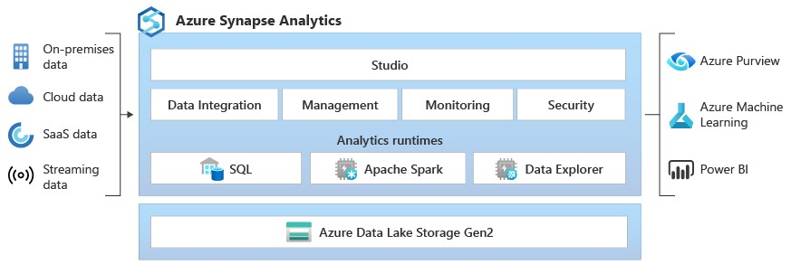

# Azure Data Factory

Azure Data Factory (ADF) is a **cloud-based data integration service** that helps organizations create, schedule, and orchestrate data pipelines. Its primary purpose is to move data from multiple sources to a central storage or processing system, often serving as the “ETL (Extract, Transform, Load)” backbone in a data platform.

**Key Features:**

* **Data Movement**: Supports data ingestion from on-premises systems, cloud sources, databases, APIs, and file-based storage.
* **Pipeline Orchestration**: Enables scheduling and managing workflows to automate ETL processes.
* **Data Transformation**: Provides built-in transformations with Data Flows and can also call external compute resources like Databricks or Synapse for processing.
* **Low-Code Environment**: Offers a drag-and-drop interface for building pipelines without heavy coding.

**Use Cases:**

* Migrating data from legacy systems to Azure storage or databases.
* Automating ETL pipelines for daily or hourly data refresh.
* Integrating multiple data sources into a centralized data warehouse.
* Preparing data for downstream services such as Synapse Analytics or Databricks.

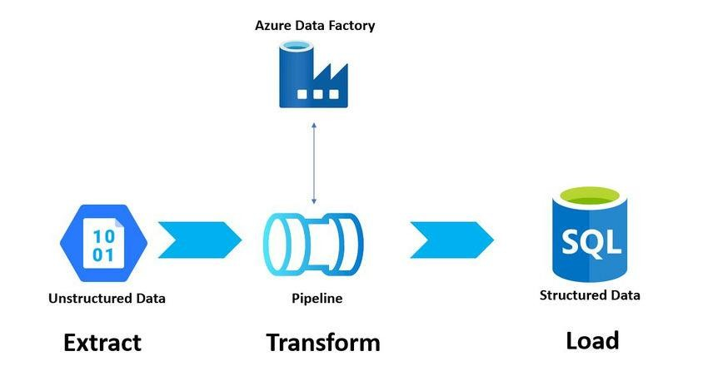

# Azure Databricks

Azure Databricks is an **Apache Spark-based analytics platform** optimized for big data processing, advanced analytics, and machine learning. Unlike Synapse and Data Factory, which focus on warehousing and ETL, Databricks provides a scalable environment for data scientists, data engineers, and AI developers to collaborate.

**Key Features:**

* **Unified Analytics Platform**: Combines big data analytics, data engineering, and AI/ML development.
* **Scalability**: Can process massive volumes of structured, semi-structured, and unstructured data.
* **Machine Learning and AI**: Integrates with ML libraries, frameworks, and tools such as MLflow, TensorFlow, and PyTorch.
* **Collaboration**: Provides interactive notebooks for teams to build and test models together.

**Use Cases:**

* Real-time and batch big data processing.
* Developing machine learning pipelines for predictive analytics.
* Processing unstructured data such as logs, videos, and sensor data.
* Building recommendation systems, fraud detection models, or natural language processing solutions.

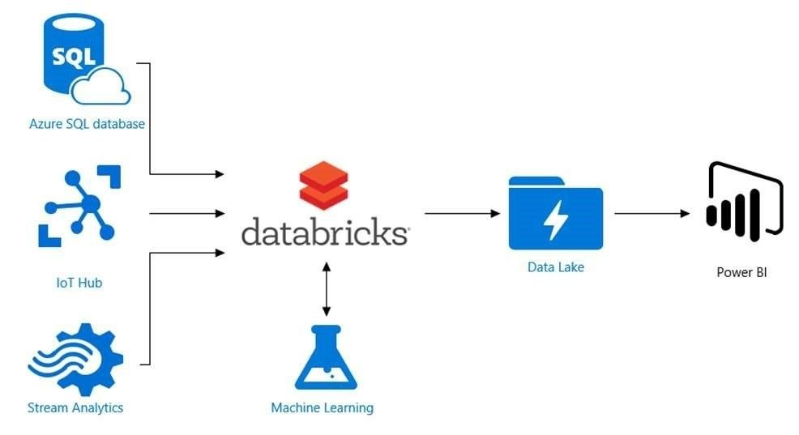

# Comparison of Synapse, Data Factory, and Databricks

|  |  |  |  |
| --- | --- | --- | --- |
| **Feature / Service** | **Azure Synapse** | **Azure Data Factory** | **Azure Databricks** |
| **Primary Purpose** | Data Warehousing &  Analytics | Data Integration & ETL  Orchestration | Big Data Processing &  Machine Learning |
| **Data Handling** | Structured & semistructured | Moves & transforms data between sources | Structured, semi-structured  & unstructured |
| **Query/Processing** | SQL-based | Pipeline-driven workflows | Apache Spark engine |
| **Target Users** | Business Analysts, BI  Teams | Data Engineers | Data Scientists, AI/ML  Engineers |
| **Integration** | Power BI, ADF,  Databricks | Synapse, Databricks, Blob  Storage | ADF, Synapse, ML frameworks |
| **Best For** | Reporting, dashboards, business intelligence | Moving & preparing data | Advanced analytics & AI solutions |

**When to Use Which?**

* **Use Azure Synapse Analytics** when the goal is to build a centralized data warehouse and run SQLbased analytics for business reporting. It is best for business users and BI professionals.
* **Use Azure Data Factory** when there is a need to orchestrate and automate data pipelines across multiple data sources. It serves as the backbone for data ingestion and transformation.
* **Use Azure Databricks** when advanced data processing, machine learning, or big data analytics are required. It is best suited for data science and real-time big data scenarios.

In practice, these services often **work together:** Data Factory ingests and moves data, Databricks cleans and transforms it, and Synapse stores it for analytics and reporting.

**Conclusion**

Azure Synapse, Azure Data Factory, and Azure Databricks each serve distinct purposes in the Azure data ecosystem. While Synapse focuses on structured data analytics, Data Factory ensures seamless movement and orchestration of data, and Databricks brings powerful big data and AI capabilities. Together, they form a robust end-to-end data platform that allows organizations to unlock the true potential of their data.

By understanding the differences and complementary nature of these services, organizations can choose the right tool for the right task and design scalable, efficient, and future-ready data solutions.

A **short and simple explanation** you can use to quickly understand the difference:

* **Azure Data Factory (ADF)** – Think of this as the **data mover and organizer**. It collects data from different places, transforms it, and sends it where it needs to go. It’s like a delivery service for data.
* **Azure Synapse Analytics** – This is the **data warehouse and analyzer**. Once data is stored, Synapse helps you run SQL queries, create reports, and do business analytics. It’s mainly used by analysts to get insights.
* **Azure Databricks** – This is the **data scientist’s and engineer’s tool**. It can handle huge amounts of structured and unstructured data, build machine learning models, and do advanced analytics.

**Easy way to remember:**

* **ADF = Move data**
* **Synapse = Analyze data**
* **Databricks = Process & model data**

# Pipeline and ETL in context of the three services

* **Azure Data Factory (ADF)** – This is where **pipelines and ETL mainly happen**.
  + **Pipeline** = a workflow that moves data from one place to another.
  + **ETL (Extract, Transform, Load)** = ADF extracts data from sources, transforms it (cleaning, formatting), and loads it into storage or Synapse.
* **Azure Synapse Analytics** – Here, you usually do **ELT (Extract, Load, Transform)** instead of heavy ETL.
  + Data is loaded into Synapse first, and transformations are done using SQL inside Synapse.
  + Pipelines can be created in Synapse too (it has built-in ADF pipelines), but its main role is **analysis, not ETL**.
* **Azure Databricks** – This is for **big/complex transformations in ETL**.
  + If data needs heavy processing (machine learning, big data cleaning), Databricks is used inside the ETL pipeline (often triggered by ADF).

**simple flow** (Data source → ADF pipeline → Databricks transform → Synapse warehouse → Power BI)